2/5/2025

SHOUHAM. B.BANERJEE
21CH10062
Analysis of VC Funding
B-Tech Project - Rajendra Mishra School of Engineering Entrepreneurship (RMSoEE)
Mentor- Prof. Prabha Bhola
School- Rajendra Mishra School of Engineering Entrepreneurship (RMSoEE)
India has an estimated 26,000 startups, making it the third-largest startup ecosystem in the world, recording consolidated inflows of over $36 billion in the past 3 years with 118 “unicorns” – startups valued over $1 billion. The Indian startup ecosystem has expanded quite rapidly mainly through private investments including seed, angel, venture capital, and private equity funds, with technical support from incubators, accelerators, and the government.
The government, for its part, is creating an enabling environment through its flagship Startup India initiative, which came into force in 2016. With India pushing toward a knowledge-based and digital economy, the government is attempting to deploy ICT infrastructure and provide policy support for enhanced e-governance, investments, and technology innovation through research and higher education to support entrepreneurship and spur economic growth. Data suggest that the expansion in the startup ecosystem has largely been clustered in the large (Tier 1) cities and states with financial depth, and especially in IT-enabled sectors including e-commerce, transport, and finance.
Small businesses beyond the metros are not fully aware of, or integrated into, programs that provide startups with various government incentives and tax breaks. Despite the progress made so far, Indian businesses face huge challenges, such as the unorganized and fragmented nature of the market in most sectors, a lack of clear and transparent policy initiatives that startups can tap into quickly, as well as a lack of infrastructure, a lack of knowledge and exposure, and complications in doing business. Creating more awareness of government initiatives and incentives, credit disbursement to priority sectors, promoting outreach and network benefits to Tier 2 and Tier 3 cities, as well as easing financing and tax breaks for foreign and domestic investors could improve opportunities for startups in India.
The Inflection Point for Indian Startups
The period 2014‒15 is considered an inflection point for the Indian startup ecosystem
With the emergence of six “unicorns” in those 2 years. Since then, the Indian startup
Ecosystem has evolved steadily owing to several underlying factors, including:

- Demographic dividend: 600 million citizens are still under the age of 25, with
Rising internet, smartphone, and financial penetration

- Market size: growing middle class with increasing disposable income and social
Media adoption, changing consumer demographics

- Number of startups incorporated and increasing number of active domestic and foreign angels/VC funders

- Political will: improvement in ease of doing business and conducive innovation
Environment through adoption of digital technologies and government initiatives like Startup India and Digital India and establishing regulatory infrastructure

- Higher education: India has a huge pool of engineering and technical graduates.

- Spill over effects from large, listed (and unlisted) technology firms: many
Angel investors and a growing pool of experienced serial entrepreneurs.
Types of Funding Avenues Available for Indian Startups

Financing for startups in India has followed the Anglo-Saxon model, which encourages entrepreneurial activity through financing from private and venture capital, as they are considered too risky by banking institutions. Venture capital (VC) and private equity (PE) are not regulated as in Europe. Financing avenues extend from friends and family at the very early stages, then move to seed/angel investors, and finally VC and PE money. Once the company is well established, it can then take on debt from banks, closed-end funds, and investment banks once they are ready to absorb late-stage investments, and edge towards listing an initial public offering (IPO).
Besides Seed, VC, and PE funding, accelerators have also helped the startup ecosystem grow. The big trend in the past 3–5 years has been various accelerator programs – a type of accelerator sponsored by a profitable company in a bid to discover and evaluate new technologies and solutions by providing grants, paid pilots, or joint go-to-market options, while they charge a flat fee or acquire an equity stake of 6%‒8% in the startups they help.
Accelerator and incubation programs span the following formats:
- Corporate accelerator programs by multinational companies (MNCs) such as Google and Microsoft, etc. and Indian groups such as Reliance, etc.
- Public–private partnerships (PPPs) such as T-Hub, T-Labs, Startup Village, etc. Department of Science and Technology (DST)-approved technology business incubators (TBIs), often in universities.
- College/university-based incubators in the nation’s premier institutions such as IIMs and IITs.
- Industry-led incubator/accelerator programs such as NASSCOM 10,000 Startups.
- Private accelerator programs, often led by VCs, such as Axilor Ventures, Sequoia Capital’s Surge, and others.
- Government-sponsored programs such as iStart Rajasthan and Kerala Startup Mission

Trend Analysis of PE/VC Investments in Startups.

Our Analysis comprises data of over 350 Startups which have successfully raised funding in the last 1-1.5 Yrs. The Objective of this analysis is to understand Venture capital outlook and provide perspective into what the future of Indian Entrepreneurship beholds. We will observe the distribution of Funding, Sector Wise, as well as Geographic Distribution of startups will also be studied. The Distribution of Funding Rounds in the overall Funding Cycle will also be looked into Detail. We will try to complete our Analysis by appropriately understanding the influence of educational excellence and corporate work experience in the probability of a successful funding. Then we would conclude our research by providing insights into the possible reasons for the above trends and its utility to provide impetus to Innovative Ideas.
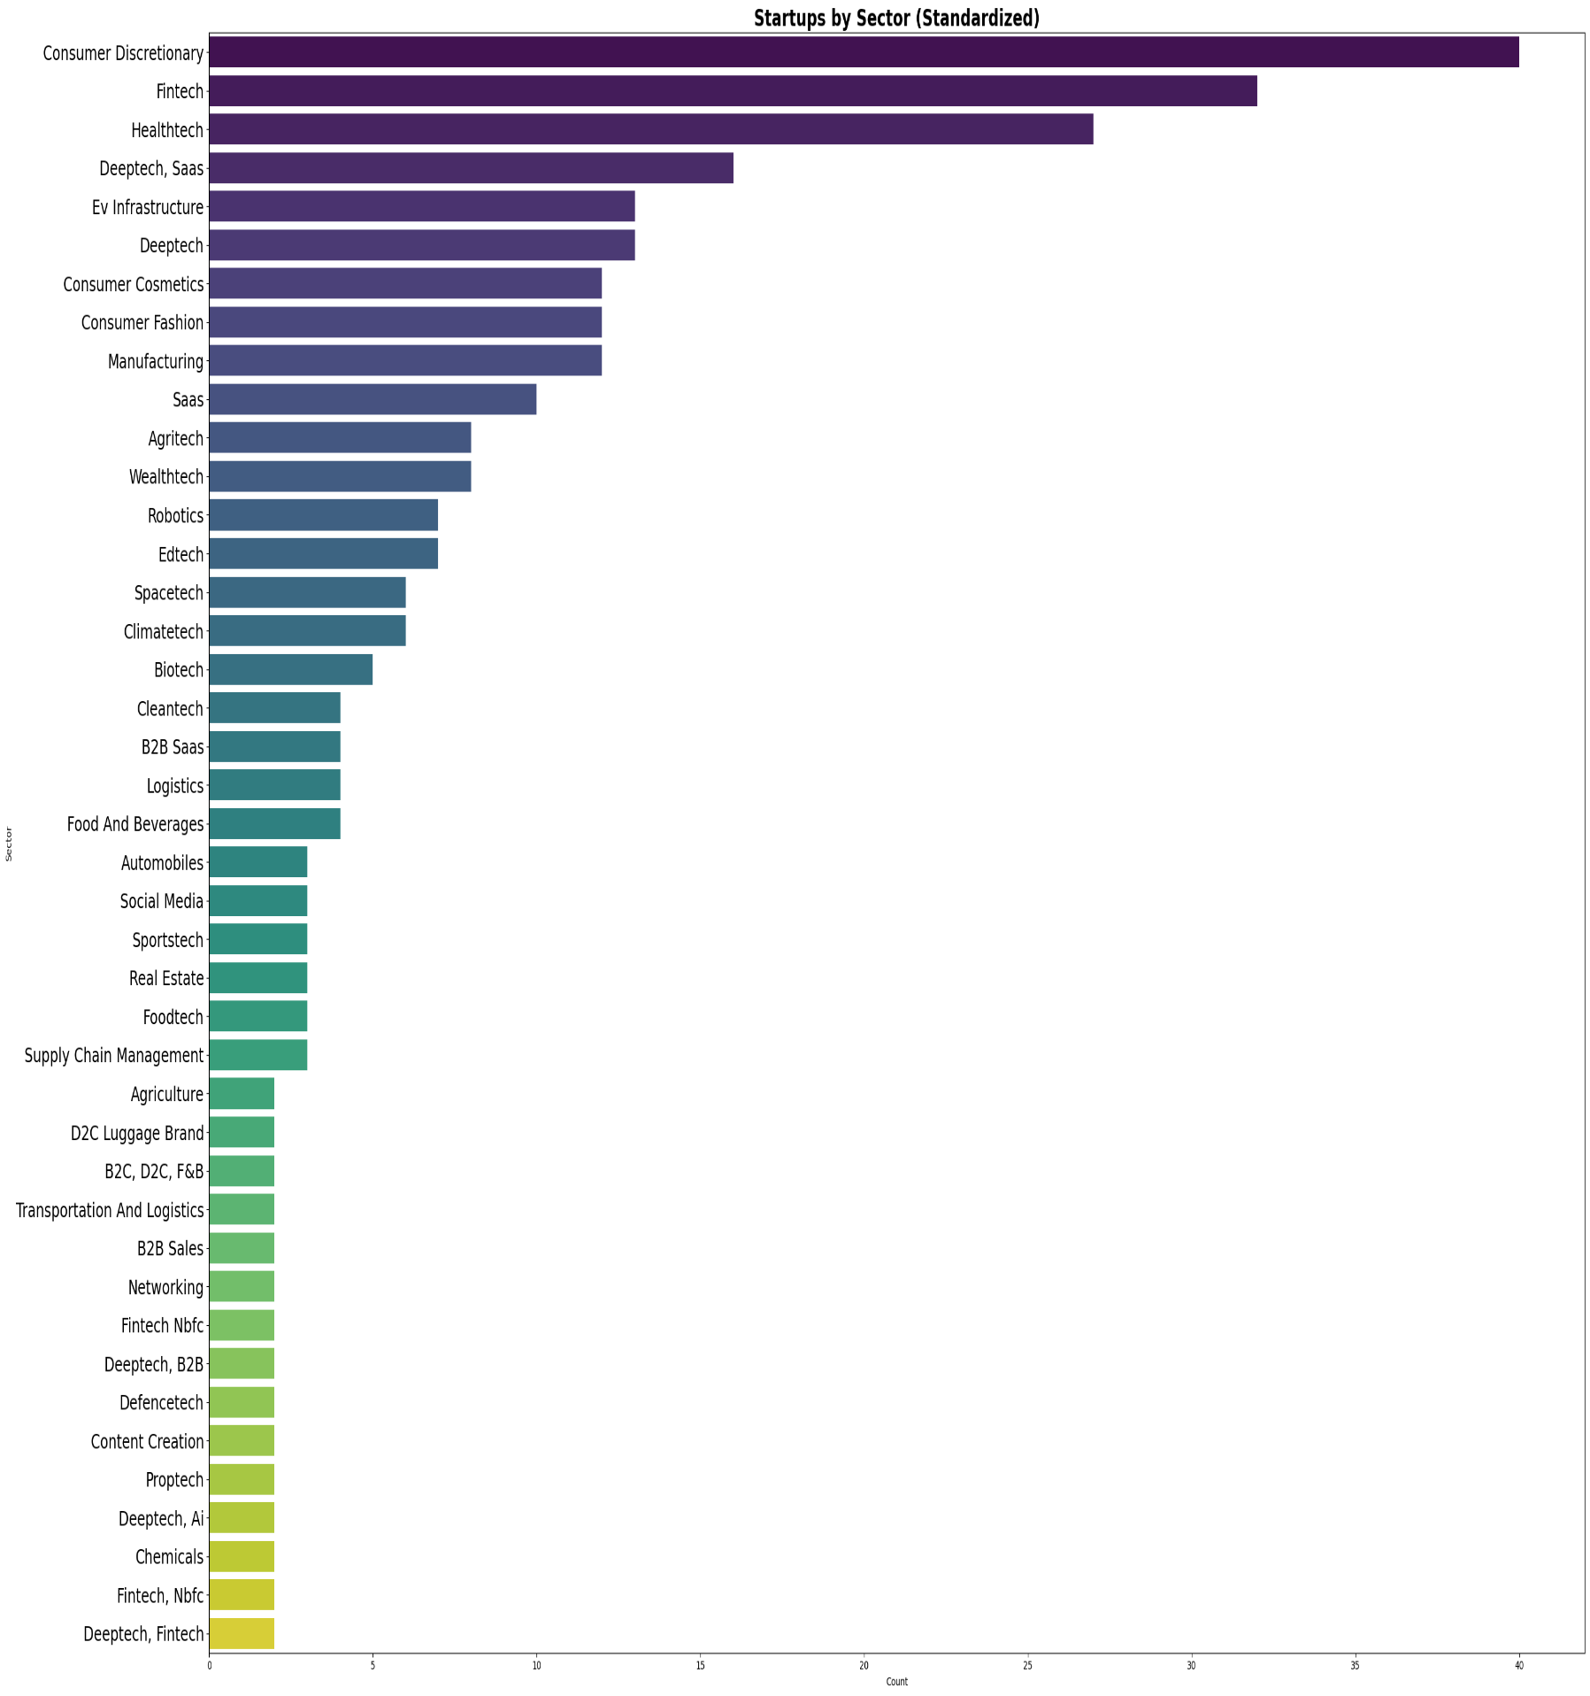
Funding Activity in Terms of Number of Deals and Sector.

Fig 1(a). Sector(X-Axis) and No. of Startups(Y-Axis

The Above Figure is a plot wherein we have done a segregation on the basis of Sector and the startup Count. Several Key insights are obtained in this plot.
- Consumer Discretionary continues to lead in term of Total Number of startups.
- Fintech continues to remain investor favourites post the UPI era due to rapid innovation in digital payments infrastructure and adoption of Artificial Intelligence continues to propel its growth.
- HealthTech is another behemoth in this race of grabbing VC funding. Adoption of Machine learning Models, Especially Deep Learning and Reinforced Learning tools is rampant in this sector.
- DeepTech and DeepTech SAAS has emerged as sectors with maximum potential for innovation and disruption, with greater focus on ventures working on Generative Artificial Intelligence, Large Language Models and Reinforced Learning Frameworks.
- EV Infrastructure has gained traction due to Government support, Tax Incentives and push for green energy targeting a Carbon Neutral Future.
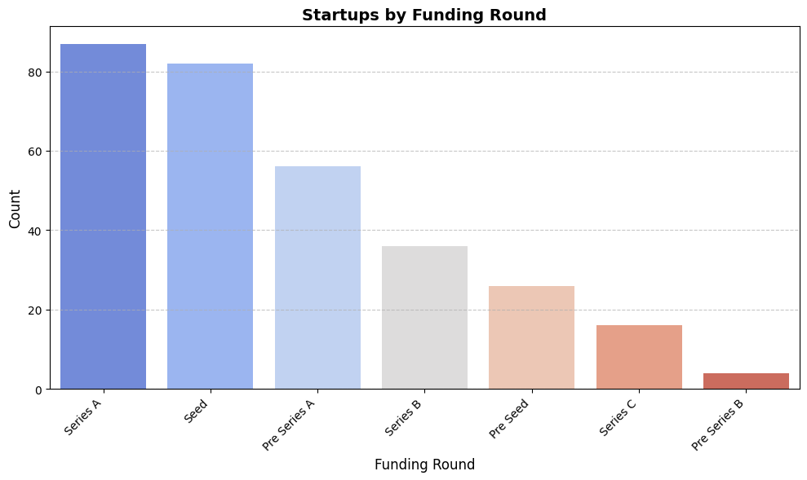
Fig 1(b). Funding Round(X-Axis) and No. of Startups(Y-Axis)
This Plot helps us understand the distribution of Funding Rounds across the startup Landscape. The Few Interesting Insights are as follows: -
- Pre-Series A and Series A combined hold a 43% Share in total Funding Received suggesting that investors actively invest in startups which already have stable revenues and market share.
- Venture capitalists have pivoted towards Innovation and Experimentation supporting a large number of startups early on through Pre-seed and Seed Funding Rounds, contributing to 33% of total Funding.
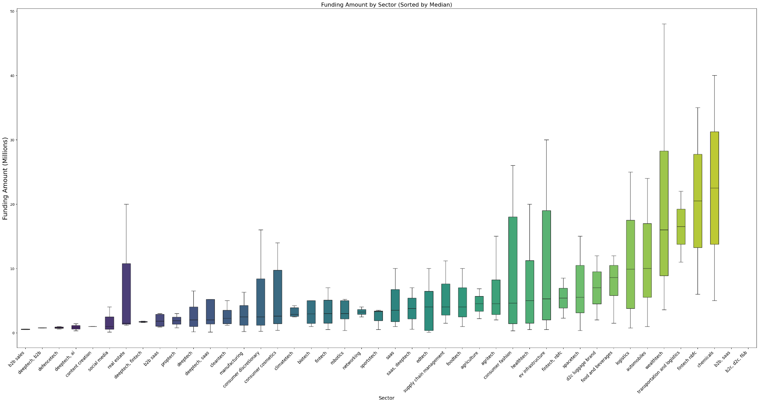
Funding Activity in Terms of Funding Amount and Sector

Fig 2. Sector(X-Axis) and Funding Amount (Y-Axis)

This is one of the most interesting graphs. Our Earlier analysis involved comparing the numbers of Startups in a particular sector but here we also do a side by side comparison with the total amount of Funding Raised.
- The Biggest Candle belong to the WealthTech Sector with Median Funding north of $15 Million. A high close to $50 Million is also observed. The Wealth Management Space with Wealth-Tech Startups like DEZERV, Stable Money, Centricity, InvestorAI, and Neo Wealth Management looks poised for future growth driven by a expanding middle class and robust growth in capital markets.
- The Fintech (NBFC) space has shown substantial resilience raising a median funding of 20 $Million. The Sector itself has a projected CAGR of 18-20%, with Tech Enabed NBFC’s using embedded finance driving future growth.
- The Chemical space has also attracted substantial funding with median funding close to $20 Million. Indian chemical manufacturing sector is a $220+ billion industry and Startups like Scimplify are disrupting this market with their Innovation.
- EV Infrastructure Space has shown resilient funding due to government support inline with the vision of being India Being Carbon Neutral by 2070, with median Funding of $5 Million and the upper Quartile of $20 Million.
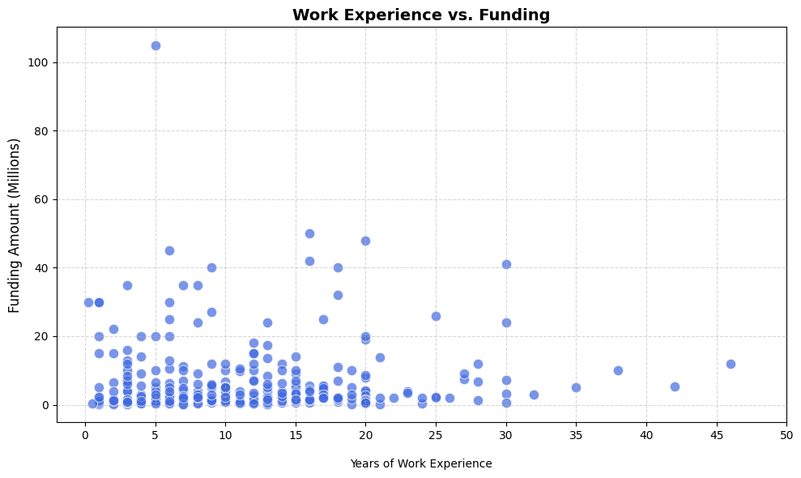
Analysis on the Work Experience of the Founders.
Fig 3. Years of Work Experience(X-Axis) and Funding Amount (Y-Axis)

A Scatter Plot showing the relation between the Funding Amount and the Work Experience of the Founder. We Obtain a few Interesting Insights through this graph.
- The 0-15 Year Work Experience Horizon is the most optimal attracting the maximum amount of funding concentration.
- The 0-20 Million Funding Range is the most Common with over 90% of the data lying within this range.
- This confirms the belief that Moderate to high work experience (5–15 years) generally increases the probability of funding, especially from institutional investors like VCs and PE funds.
- Very high work experience (20+ years) may correlate with lower startup activity or less risk-taking behaviour, especially in younger ecosystems.
- Younger founders (<3 years exp) may attract seed funding more easily if tech-driven (e.g., in SaaS, AI, fintech), especially from angel networks or accelerators.
- Founders with previous startups (even failed ones) are seen as more fundable. Some investors favour younger founders (<35) for scalability, energy, longer time horizon. Early-stage (idea/pre-seed) may favour young & bold; growth-stage favours experienced operators.
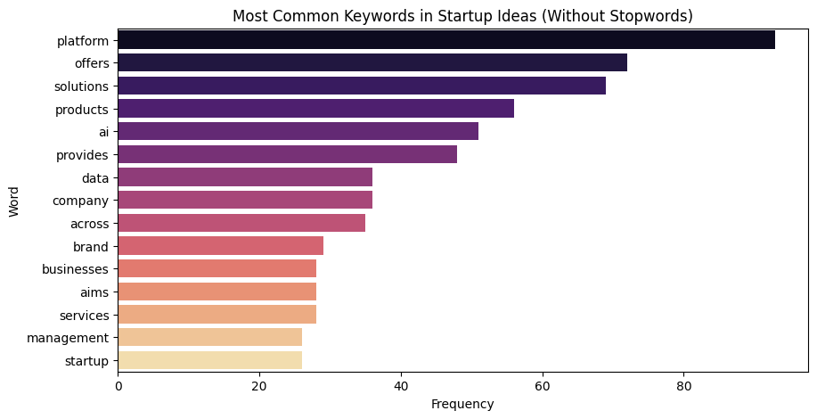
Text Vectorization of the “Startup Ideation” Column
Fig 4. Frequency of Occurrence(X-Axis) and Word(Y-Axis)
Vectorizing sentences to check word frequency is a fundamental step in Natural Language Processing (NLP). This process is called text vectorization, and the most basic form is the Bag of Words (BoW) model.
Bag of Words turns sentences into fixed-length vectors where each dimension corresponds to a unique word in the corpus, and values represent the frequency of that word.

Text Vectorization is executed on the dataset of the ideation column and then the frequency of word occurrences is plotted. Interesting insights are as follows: -
- The first 4 Words are general services-oriented words like “Platform”, “Offers”, “Solutions” and “Products”.
- The Occurrence of AI as the fifth most used word enables to understand the scale of Artificial intelligence integration taking place in the Indian Startup Landscape. Almost every sector is adopting Artificial Intelligence to streamline daily operations.
- Data is the 6th most used word suggesting heavy influence of data science and development of Big Data Management tools in the Indian Startup Landscape.
- Occurrence of “Businesses” suggests a vibrant B2B Model in the Startup Ecosystem being supported in the VC circle. B2B Startups have Higher Order Values, Stable Cash Flows and Lower CAC’s (Customer Acquisition Costs) resulting in predictable growth prospects.
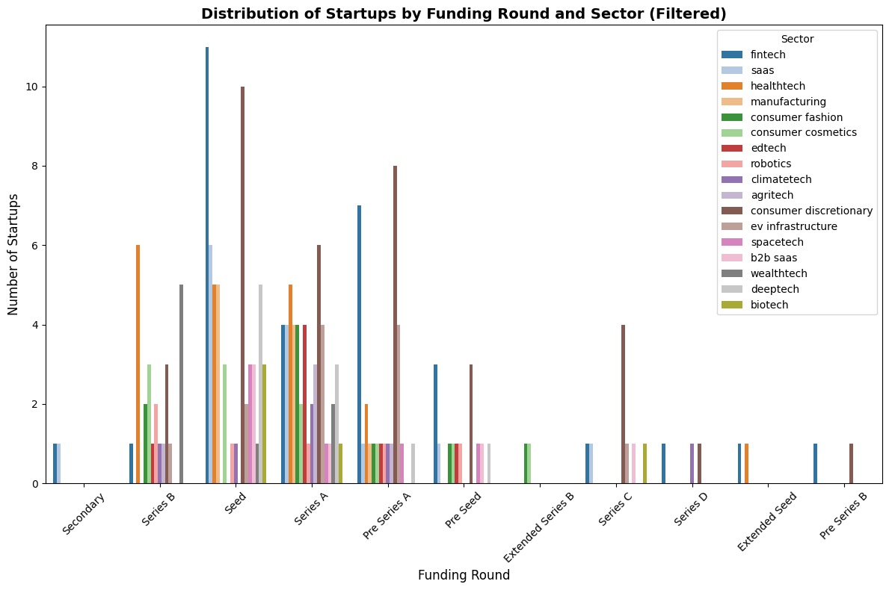
Distribution of the Funding Rounds with the Sectors
Fig 5. Funding Round(X-Axis), Sector (Bars) and Frequency of Occurrence (Y-Axis)

This Distribution is a multivariable plot showing the concentration of sectors corresponding to each Funding Round and their respective number. Some Very important Insights are obtained in this Particular plot: -
- Fintech Continues to lead the Indian Startup Movement with highest concentration in the Seed Funding Round.
- Consumer Discretionary is a very well distributed sector with Seed, Series A and Pre-Series A. D2C Brands are on a meteoric Rise with stories like Snitch, The Souled Store and Bewakoof fueling investor sentiment.
- DeepTech Startups have significantly more concentration in the Seed phase, as seen in the plot. This suggests Heavy capital Investment in a Sector which is very R&D focused and is in the nascent Stage Currently.
- HealthTech is a more Diversified Investment, finding Significant share in Seed, Series A and Even Series B Rounds. This Suggests that HealthTech as a sector is maturing and is poised for growth stabilisation in the future.
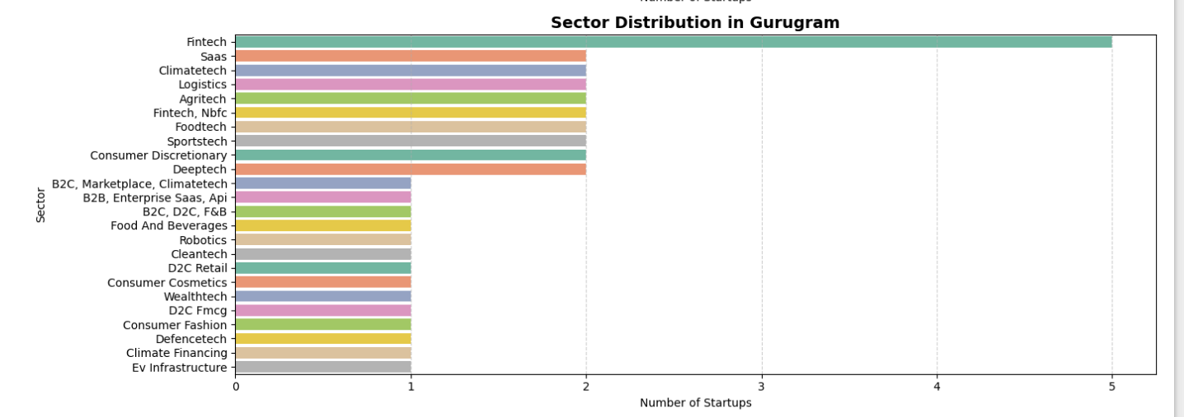
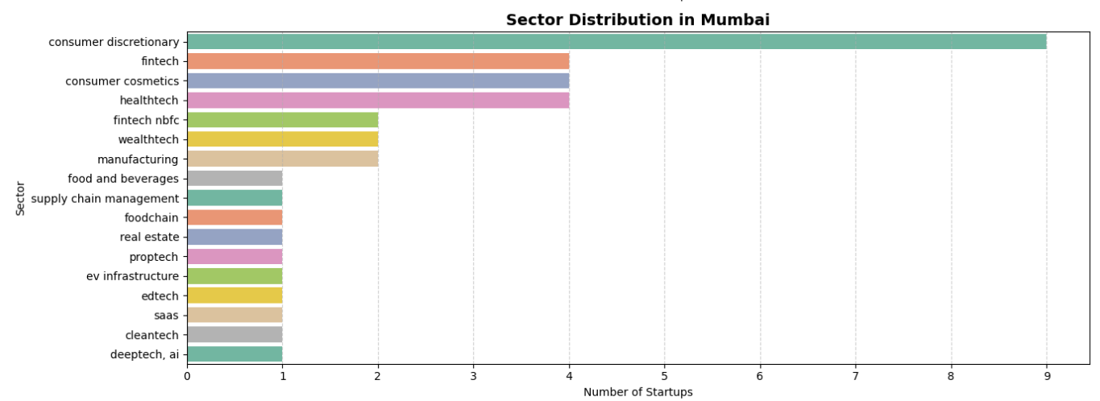
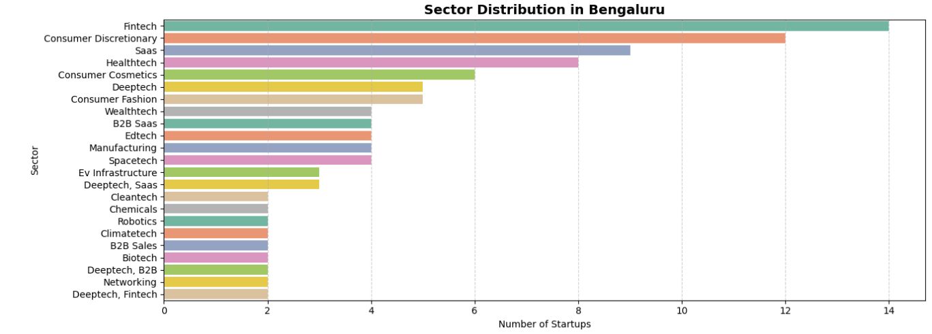
Distribution of the Sectors with the Location

Summary: -
- Venture capitalists have pivoted towards Innovation and Experimentation supporting a large number of startups early on through Pre-seed and Seed Funding Rounds, contributing to 33% of total Funding.
- Pre-Series A and Series A combined hold a 43% Share in total Funding Received suggesting that investors actively invest in startups which already have stable revenues and market share.
- The Consumer Discretionary Sector has immense growth potential, with Big Brands like Zudio giving stiff competition to emerging D2C Brands. This Sector is Ripe for Disruption consequently attracting the largest amount of VC Funding, with stories like Snitch, The Souled Store, Bewakoof fueling Investor Sentiment.
- HealthTech continues to be a sector with presence across Funding Rounds, Geographies and a robust funding channel. With the Adoption of Deep Learning and Reinforced Learning frameworks, the future for this sector is remarkable.
- The Fintech (NBFC) space has shown substantial resilience raising a median funding of 20 $Million. The Sector itself has a projected CAGR of 18-20%, with Tech Enabed NBFC’s using embedded finance driving future growth.
- A Rising Middle Class has resulted in more Disposable Income contributing to a greater market for Wealth Management Services leading to the emergence of Wealth-Tech Startups Like DEZERV, Stable Money, Centricity, Neo Wealth Management.
- The Make-In-India Initiative has given Impetus to Startups Building EV Infrastructure, Supply Chain Solutions, Manufacturing Capacities, Robotics, Space Technology and Drone Technology cumulatively attracting 15% of Total Funding.
- The Chemicals space has also attracted substantial funding with median funding close to $20 Million. Indian chemical manufacturing sector is a $220+ billion industry and Startups like Scimplify are disrupting this market with their Innovation.
- Fintech Continues to remain an investor favourite post the UPI era due to rapid innovation in digital payments Infrastructure, coming a close second after Consumer Discretionary in terms of total deals.
- Deep-Tech Startups working on Generative AI and Large Language Models (LLM’s) have become an Investor Favourite. With the Emergence of OpenAI’s Flagship’s Product ChatGPT, India Is trying to leverage its Talent Pool to Create Artificial Intelligence Infrastructure of its own, Tapping into VC Capital to Create Innovative Disruption and create once in a lifetime opportunities.
- Relevant Work Experience has proven to be an inevitable trait for successful entrepreneurship. Moderate to high work experience (5–15 years) generally increases the probability of funding, especially from institutional investors like VCs and PE funds.
- Text Vectorization shows rapid integration of Artificial Intelligence and Machine Learning frameworks into business ideas to streamline operations. With DeepTech startups getting a significant portion of total Seed Funding, the future for DeepTech Startups looks extremely promising.
- Data is the 6th most used word suggesting heavy influence of data science and development of Big Data Management tools in the Indian Startup Landscape.
- Overall the Startup Landscape in India Looks very promising with limitless potential.

